Name : Eman Khurram

SapID: 63725

Bs-Cyber Security

Programming Fundamental

Lab Task Submission

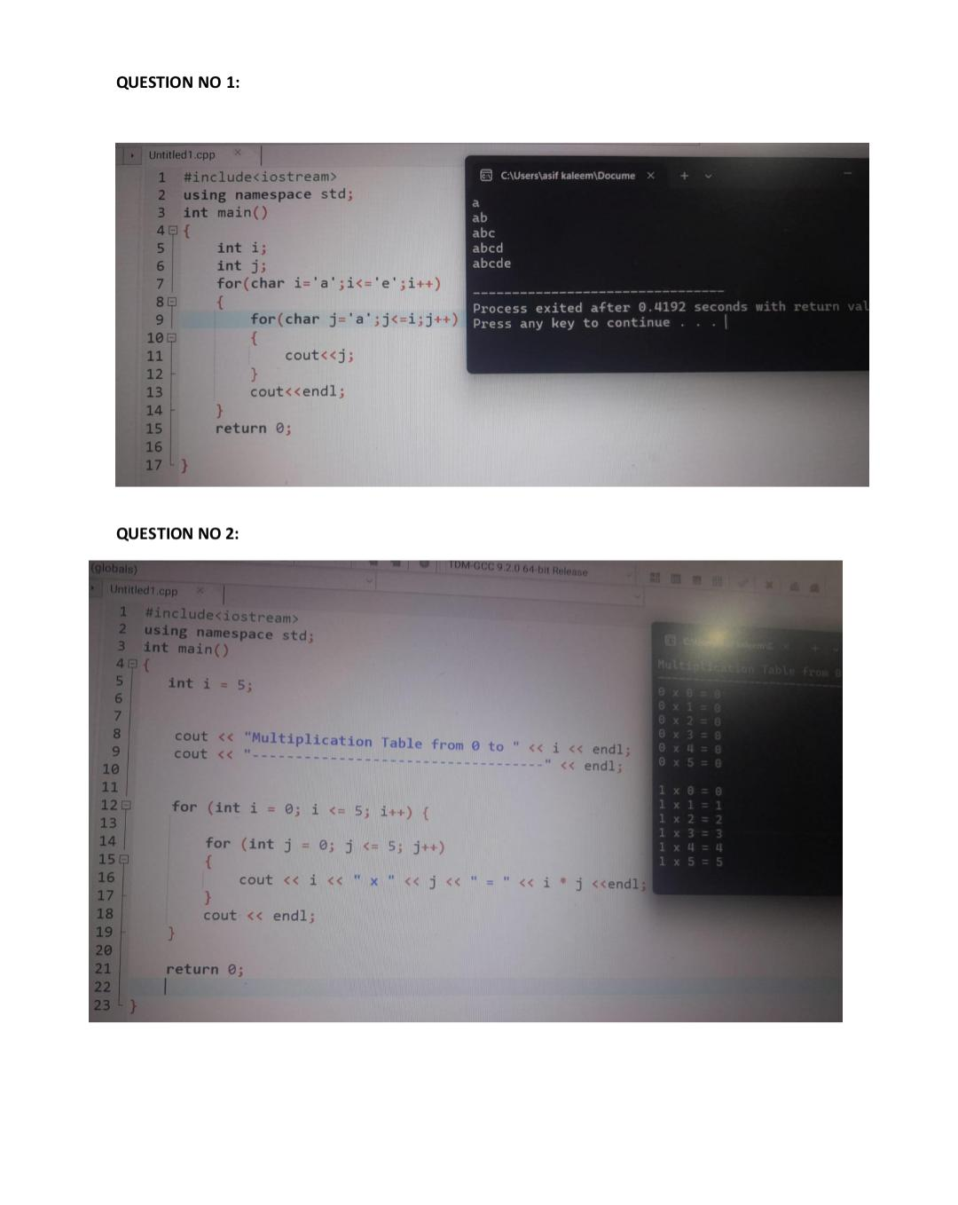

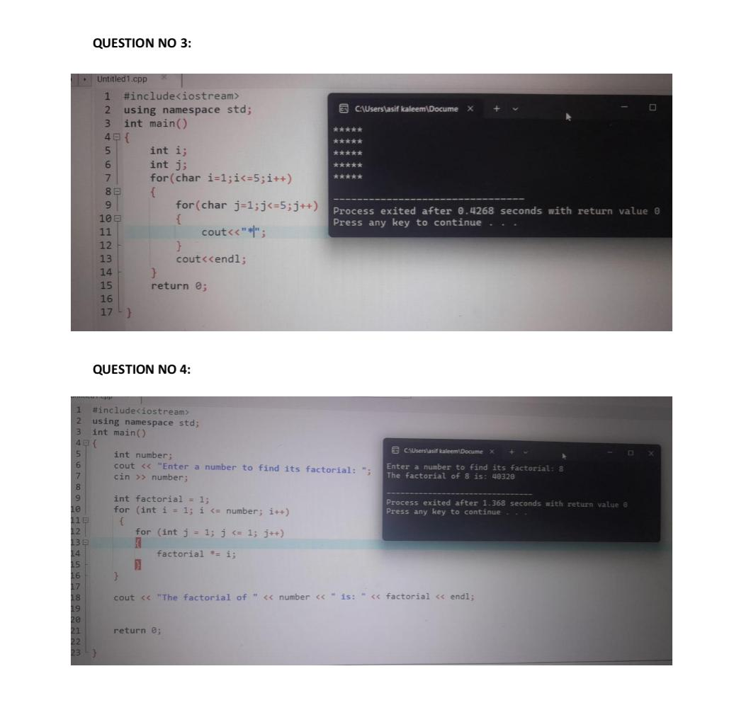

Question 5:

